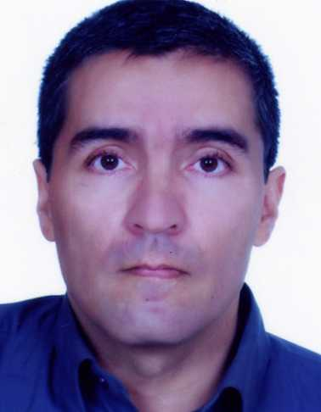

الاسم الكامل: عبدالسلام جامعي
الصفة: عضو المختبر
الرتبة العلمية: PhD
عنوان العمل: شعبة الانجليزية، كلية الآداب والعلوم الانسانية، جامعة المولى اسماعيل، مكناس. المغرب.
الجنسية : مغربي
البريد الإلكتروني:abdeslam@live.co.uk
العنوان البريدي: 9، الزنقة 43. السعادة 2. فاس المغرب.
الموقع الإلكتروني:
اللغات: عربية – انجليزية - فرنسية
الأعمال المنشورة:
PUBLICATIONS

2014: &M. Naouikhir.“Loss & Loss in the Translation of Qur’anic Narrative Discourse”. Sacred Translation in Light of Sacred Text and Islamic Exegesis.In Qur’anic Narrative and the Challenges of Translation.Darir. H, Elidrissi. M. Y, Zahid. A. (Eds). SeriesKnowledge and Translation.Issue N3. Modern Books World.Irbid. Jordan. Pp: 288-302.

2014: &M. Naouikhir.“Translation Theory and Quranic Terminology”.In Translation and Terminological Issues.QadiAyad University. Marrakech

2014: “Bridging the Gap: Virtual Learning Environment (VLE) & 21st Century Traditional Formal Learning”.In ICT in Education: Future Prospects and Potential Challenges.FLHS. Moulay Ismail University.

2013: The Omnipresence of Arabic in the Diglossic Debate. In Language and Linguistics: Arabic Sociolinguistics and Word Meaning.Jamai.A. (Ed.) Issue 31.Pp: 25-45.

2013: International Journal of Language and Linguistics: Arabic Sociolinguistics and Word Meaning. Jamai,Abdeslam (Ed.). Issue 31.

2012: Democratic access and Integration of multilingual non-indigenous minorities: Euro-Moroccans. In Migration et Hybridité: Le Paradigme Maghreb – Europe.Ennaji. M. (Ed.). Centre Sud Nord. Imprimerie El Maarif Al Jadida. Rabat. Pp: 163-82.

2012: From Immigration to Minority Status: A Moroccan Journey to Britain. In Migration et Mondialisation. Ennaji. M. (Ed). Centre Sud Nord. Imprimerie IPN. Fes.Pp: 194-221.

2012: Sacred Translation in Light of Sacred Text and Islamic Exegesis. In Translating the Rhetoric of the Holy Quran: Between Source Identity and Target Culture.Darir. H, Elidrissi. M. Y, Zahid. A. (Eds). SeriesKnowledge and Translation.Issue N2. Modern Books World. Irbid. Jordan. Pp: 467-70.

2012: Politiques d’intégration des minorités multilingue non-autochtones : le cas des marocains européens in Emigration marocaine en Espagne : problèmes actuels et nouveaux defi. Faleh. A, Cebrian. A, M. Bokbot, Serrano. J. Mª. (Eds). Universidad de Murcia. Pp: 199 – 232.

2010: “Arabic: Languages and Dialects”. RissalatTaibah. P9. V52. Sep 2010. Taibah University.Kingdom of Saudi Arabia.

2010: Language Use and Maintenance of Non-Indigenous Minorities: The British-Moroccans. Lincom Europa. Germany.

UNDER PUBLICATION

- Introduction to Understanding Translation. Lincom Europa. Germany.

Abdeslam
_____________________
Abdeslam Jamai, MA. PhD.
Assistant Professor
Department of English
Faculty of Arts and Humanities
Moulay Ismail University
B.P. 11202 Zitoune
Meknès, Morocco
Phone: +212 (0) 63 139 8014
Fax: +44 (0) 844 443 9494
Email: abdeslam@live.co.uk
Skype Name: ab.deslam

